**Страноведение. США.**

[Карта США](http://states-of-america.ru/karty-ssha/)

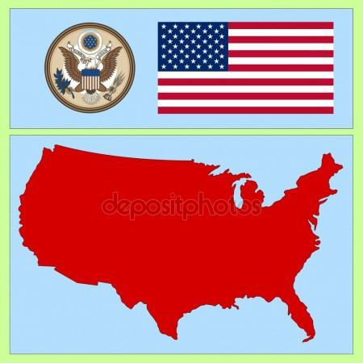

Эмблема США

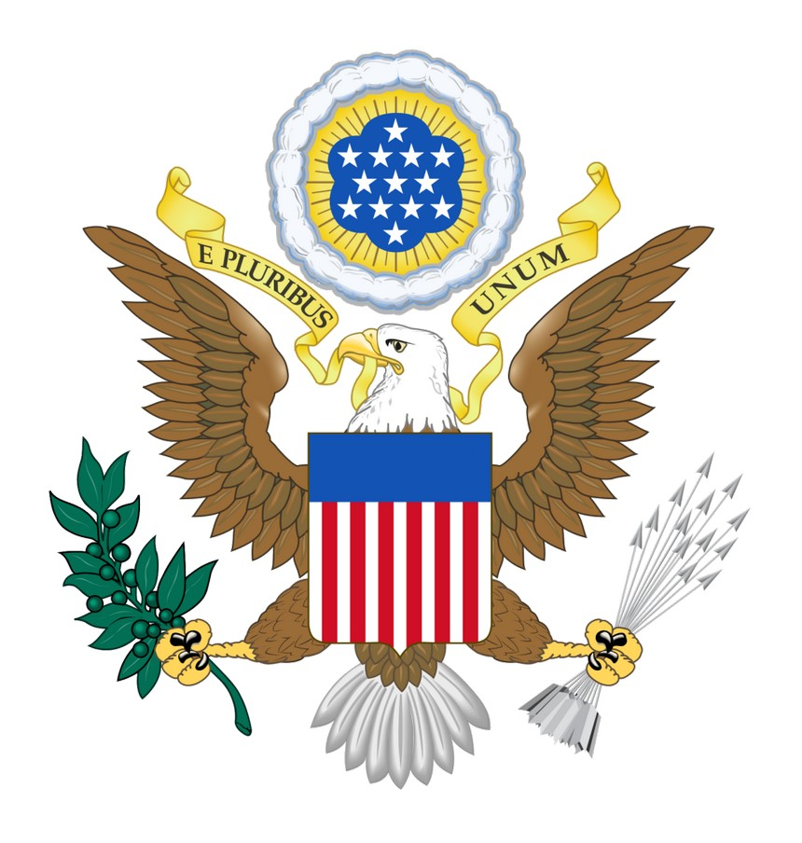

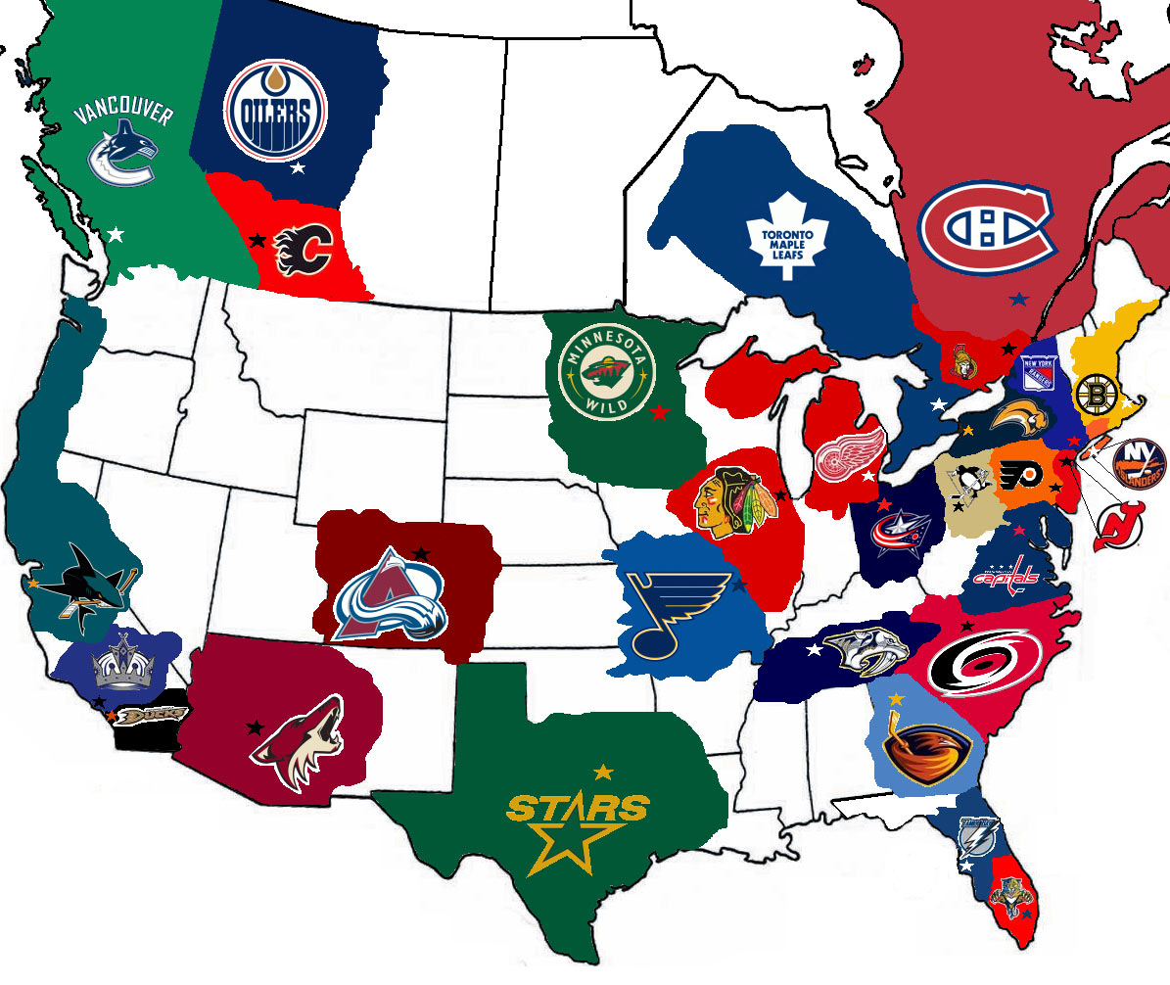

[Гимн США](http://music.yandex.ru/#!/track/787256/album/87715)

[Столица США - Вашингтон](http://www.americansights.ru/cities/washington)

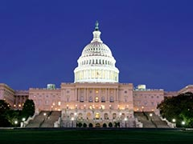 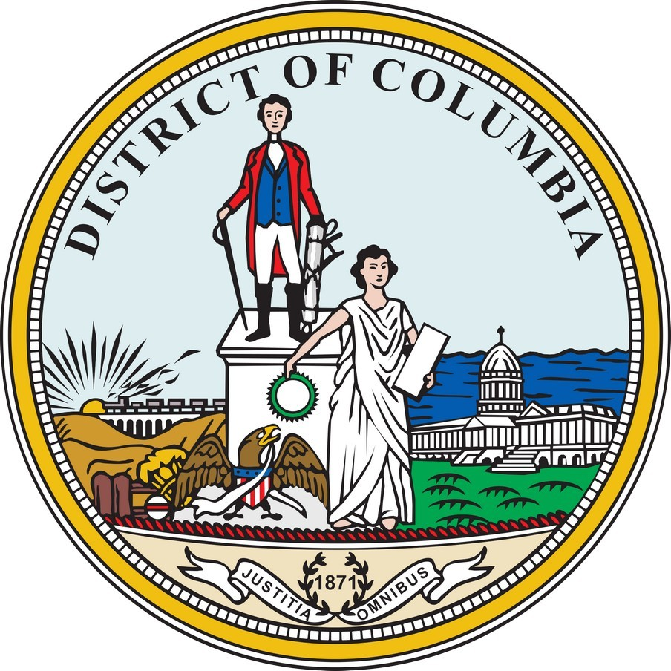

**Страноведение. Великобритания.**

# London http://i.g-superwebsite.ru/u/e9/5b278a67e1771c531b44884e770f9e_500cea2d/-/london.jpg

# 

# Страноведение. Великобритания.

**London is the biggest city in Britain and in Europe.**

**London occupies over 620 square miles**

**London has a population of 7,172,036 (2001)**

**About 12 per cent of Britain’s overall population live in London**

**London has the highest population density in Britain, with 4,699 people per square kilometre,**

**London is in the southeast of England.**

**London is the seat of central government in Britain.**

**The tallest building in London is the Canary Wharf Tower.**

**London was the first city in the world to have an underground railway, known as the 'Tube'.**

**Some of the most important people from countries all over the world visit the Queen at Buckingham Palace.**

**There are over 100 theatres in London, including 50 in the West End. London theatre accounts for 45% of all UK theatre admissions and over 70% of box-office revenues. Source: GLA Economics**

## [Introduction to Britain](http://projectbritain.com/britain.html)

[Queen Elizabeth II](http://projectbritain.com/theQueen.htm)

        Elizabeth Alexandra Mary, this is the full name of the Queen, became queen at the age of 26 when her father, King George VI, died while on an official tour of Kenia in 1952.    
Quite a number of Brits consider having to play the role of the queen to be a very difficult job which prevents you from having a normal lifestyle. By the way, the majority of people in Britain think the Queen is doing her job of representing Britain around the world excellently and very professionally. In her country she does charity work and participates in various events of symbolic importance

## [The Royal Family](http://ru.wikipedia.org/wiki/Британская_королевская_семья)

### [The latest news](http://www.newsru.com/dossier/6224.html)

## [The Royal Family Tree](http://projectbritain.com/royaltree.htm)

How much do you know about the British Royal Family?

[Quiz: Jubilee](http://www.bbc.co.uk/worldservice/learningenglish/quizzes/quiznet/2012/05/120530_flash_quiz_4_diamond_jubilee.shtml%20)

**London is the biggest city in Britain and in Europe.**

**London occupies over 620 square miles**

**London has a population of 7,172,036 (2001)**

**About 12 per cent of Britain’s overall population live in London**

**London has the highest population density in Britain, with 4,699 people per square kilometre,**

**London is in the southeast of England.**

**London is the seat of central government in Britain.**

**The tallest building in London is the Canary Wharf Tower.**

**London was the first city in the world to have an underground railway, known as the 'Tube'.**

**Some of the most important people from countries all over the world visit the Queen at Buckingham Palace.**

**There are over 100 theatres in London, including 50 in the West End. London theatre accounts for 45% of all UK theatre admissions and over 70% of box-office revenues. Source: GLA Economics**

## [Introduction to Britain](http://projectbritain.com/britain.html)

[Queen Elizabeth II](http://projectbritain.com/theQueen.htm)

Elizabeth Alexandra Mary, this is the full name of the Queen, became queen at the age of 26 when her father, King George VI, died while on an official tour of Kenia in 1952.    
Quite a number of Brits consider having to play the role of the queen to be a very difficult job which prevents you from having a normal lifestyle. By the way, the majority of people in Britain think the Queen is doing her job of representing Britain around the world excellently and very professionally. In her country she does charity work and participates in various events of symbolic importance

## [The Royal Family](http://ru.wikipedia.org/wiki/Британская_королевская_семья)

[The latest news](http://www.newsru.com/dossier/6224.html)

## [The Royal Family Tree](http://projectbritain.com/royaltree.htm)

How much do you know about the British Royal Family?

[Quiz: Jubilee](http://www.bbc.co.uk/worldservice/learningenglish/quizzes/quiznet/2012/05/120530_flash_quiz_4_diamond_jubilee.shtml%20)

**Работы учащихся в сети интернет**

**Интернет-конкурс детских виртуальных экскурсий**

["Мир вокруг нас"](http://www.it-n.ru/board.aspx?cat_no=107408&tmpl=Thread&BoardId=330349&ThreadId=543008&page=3)

[Мой любимый фильм](http://nsportal.ru/ap/drugoe/library/moi-lyubimyi-film-1)

**Современные ИКТ в помощь учителю**

**Prezi**

    Учителю, втянувшемуся в использование ИКТ в образовательном процессе, всегда хочется чего-то большего, чем банальное чередование слайдов в программах MS PowerPoint или Open Office. Нужны новые технологические решения, которые максимально бы облегчили труд учителя и помогли бы создавать оригинальные и эффективные разработки. К этой группе решений можно отнести и венгерскую программу Prezi, которая уже успела восхитить не одну тысячу пользователей. Главное достоинство в том, что в Prezi можно легко подготовить нелинейные, многоуровневые презентации. Помогут Вам следующие сайты:

[**Prezi.com**](http://mainprezi.blogspot.com/) - записки начинающего

Руководство пользователя **.**