[https://im0-tub-ru.yandex.net/i?id=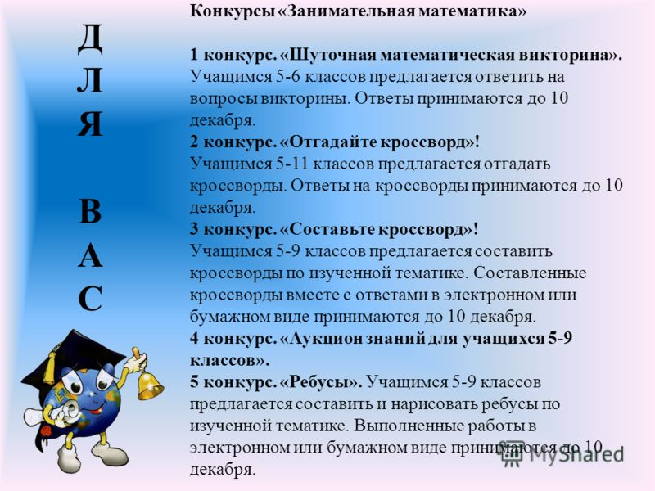df86419e72d82fa9ac2a694dca1367e6&n=13](https://im0-tub-ru.yandex.net/i?id=df86419e72d82fa9ac2a694dca1367e6&n=13)