**Контрольный срез 9 класс**

1. **Form compound adjectives using the words below**

***Three, blue, well, deep, good***

1. Sam is a very …looking man.

2. I had a nightmare about a … headed monster.

3. My nephew is a cute little … -eyed boy.

4. The Kraken was a … - sea monster from Norwegian legend.

5. Nessie is a … - known monster from Scotland.

1. **Put the verbs in brackets into the correct future tense: *future simple, future perfect, future continuous, future perfect continuous.***

1. The film …. (start) by the time you arrive.

2. I cant go out on Saturday or Sunday night. I …. (study) all weekend.

3. He …. (drink) three litres of water by the end of the day.

4 What …. (you/tell)him about the printer?

5. She …. (play)football for three years in June.

1. **Complete the sentences with the correct comparative/superlative form of the adjectives/adverbs in brackets.**

1. She came …. (late) than we expected.

2. That was …. (bad) film I have ever seen.

3. She works …. (carefully) than others.

4. He is …. (intelligent) of all.

5. My mum is ….. (talented) artist in my family.

1. **Read the text and mark the statements below it as T (true), F (false) or Ns (Not stated)**

**Pop Art**

What is art? In the 1960s a collection of artist made that question even more difficult to answer. They created Pop Art, a style of art that represented everybody’s everyday experiences. Pop artist were fascinated by realistic images from everyday life that everybody saw. One element of life they noticed was that almost all people are consumers who buy and use millions of different things every day. As a result, many Pop artists used images of products from the supermarket or advertisements in their works.

The most famous Pop artist was the American Andy Warhol. Warhol painted products like Campbell’s Soup, Coca Cola bottles and bananas. He also painted other everyday images. For example, his bright portraits of celebrities like Marilyn Monroe, the famous actress, became very fashionable. The British Pop artist Eduardo Paolozzi collected pictures and advertisements from magazines to use in his works. Another well – liked Pop artist was Roy Lichtenstein. Instead of using products or advertisements, most of his works were similar to images in the comic books that children read every day.

Many people in the art world do not accept Pop Art as a real art from. They can’t see why a dull painting of an ordinary can of soup should be part of an art exhibition. However, many original Pop Art works have sold for millions of dollars. Many works have also appeared on music album covers. All in all, the most important result of Pop Art is that is has created a new artistic way of looking at the everyday world.

1. Pop artists were interested in people’s everyday experiences. ……….

2. Pop art was only in America. ………..

3. All Pop artists used images of products in their works. ………

4. Palozzi was only famous in Britain. ……..

5. Marilyn Monroe was a Pop artist who painted celebrities. ……..

6. Pop Art hasn’t been very popular with some people. ……….

7. Some Pop artists never sold their works. ………

**Контрольный срез 8 класс**

1. **Match the questions with their responses.**

|  |  |
| --- | --- |
| 1. Do you have a part- time job? 2. Did your dad get a promotion? 3. What does Tony do for a living? 4. Does Sam work in an office? 5. How long has she been working for this company? 6. How are things at work? 7. How does she like her job a nurse? 8. Did you hear that Joe lost his Job? 9. What exactly does her work as an operator involve? | A) He’s a graphic designer.  B) No. He works as a freelancer from home.  C) For two years.  D) I’m afraid he didn’t.  E) The same as ever.  F) Really? What happened?  G) No, I work 9-5 Monday to Friday.  H) She connects telephone calls at a telephone exchange.  I) She hates working the night shift. |

1. **Fill in the gaps with either past perfect or past perfect continues**
2. I ……… (wait) at the cinema for an hour before Kim finally showed up.
3. Grandma ……... (go) to the supermarket before they got home from school.
4. They ………. (play) football all day so they were very tired in the evening.
5. ………… (he/finish) making the lunch when the guests arrived?
6. I …..….. (look) for a new bike for two months before I found one.

**III. Rewrite the following sentences into the passive.**

1. John Napier designed the costumes for Cats.
2. They serve dinner from 7:00 pm onwards.
3. They have translated the book into 25 languages.
4. The company will publish the new Harry Potter book next month.
5. Has Brenda sent the invitations yet?

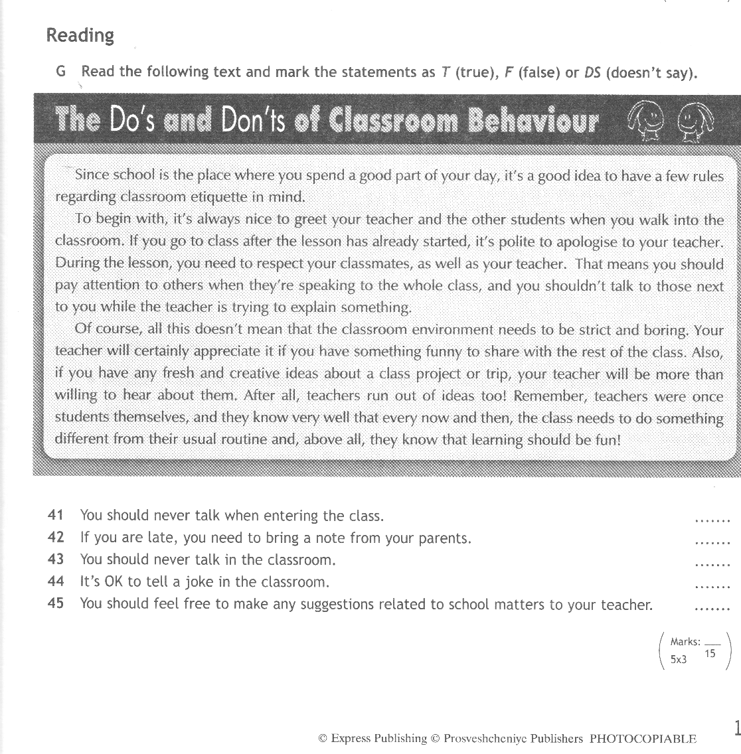IV*